**Report of Week#5**

**All:**

We have planned the first steps. Created trello for our team, where we writing our progress (<https://trello.com/to45>)

**Sultan Aitkali and Dikanbayeva Assura**

Drew an approximate design of web pages,came up with a dialogue in the bot.

**Valiyeva Nassiba, Dyussenova Anel, Tazhibayeva Aidana:**

Drew a database diagram, came up with a dialogue in the bot.

**Dikanbayeva Assura:**

Created figma for this project: https://www.figma.com/file/AdWMCo0J4mYbwEPPEgbO3Y/Diploma-landing-page?node-id=0%3A1

Doctor’s Cabinet:

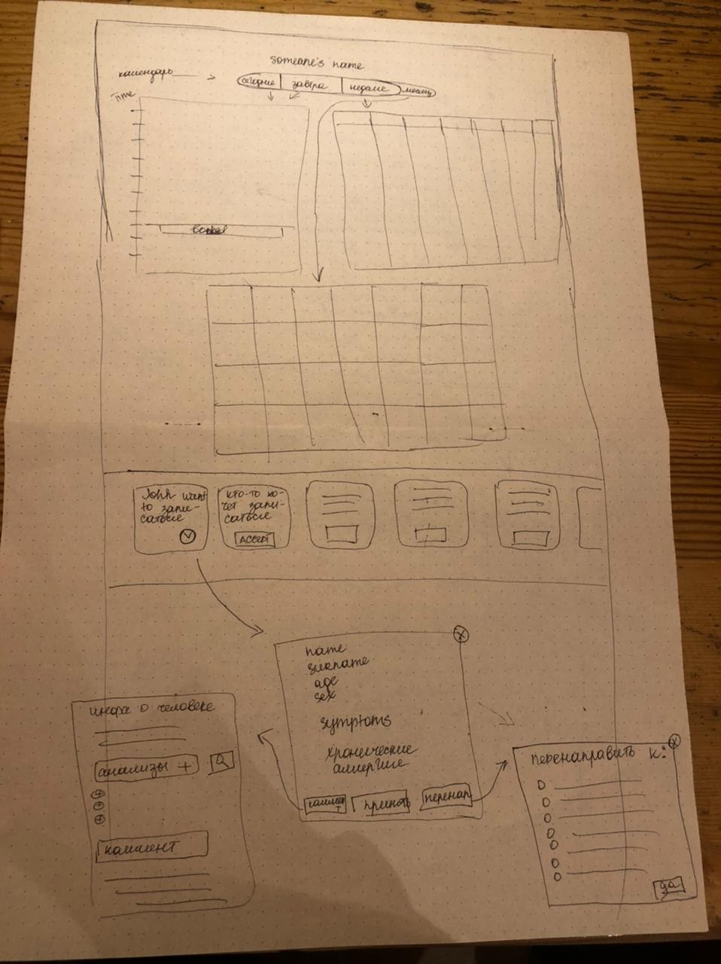

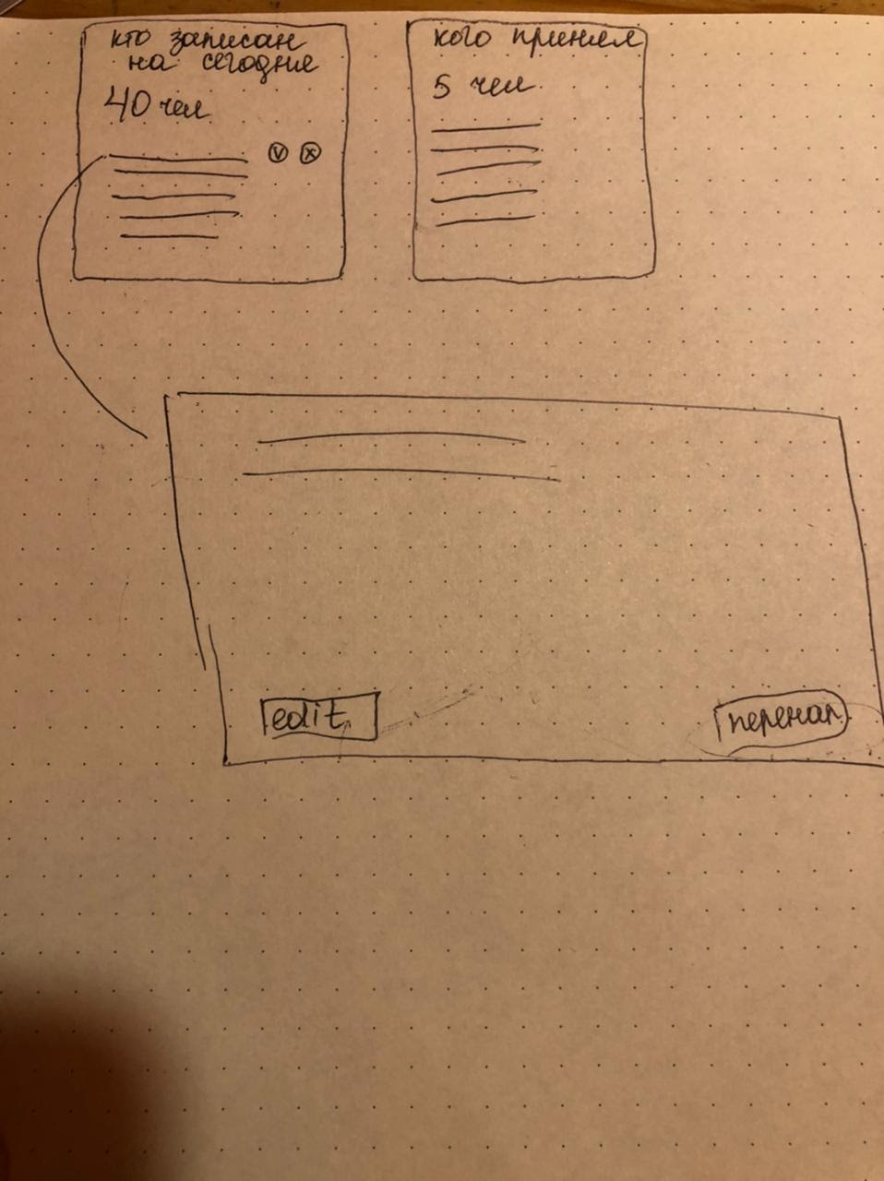

Telegram Bot Dialogue and Doctor’s Profile

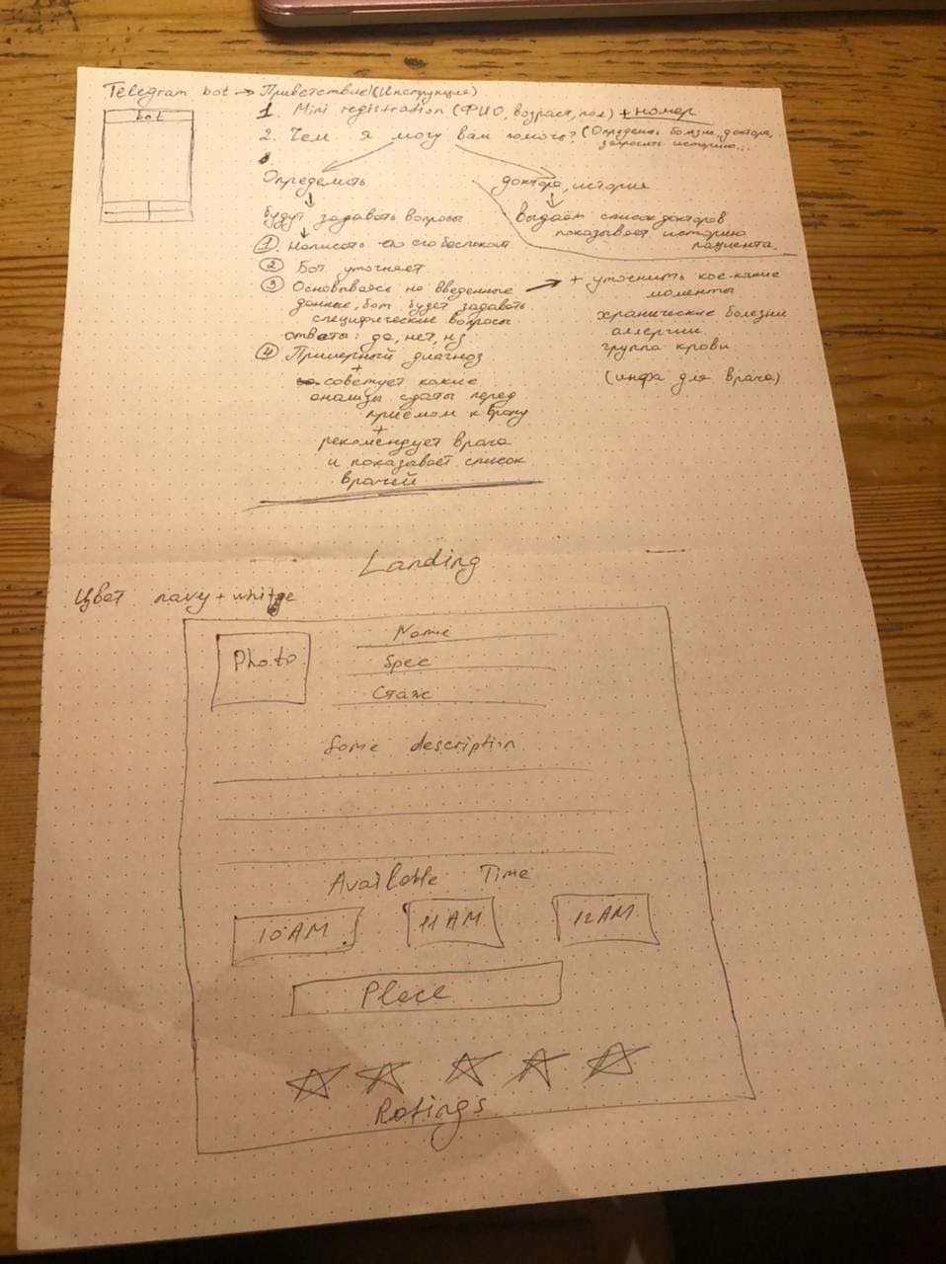

Database Diagram:

